**Mini Project Report**

on

**Version control and Code management system**

Submitted by

PES1UG19CS343: Pranav R. Hegde

1**: Activity Diagram:**

i) The below activity diagram represents login use case

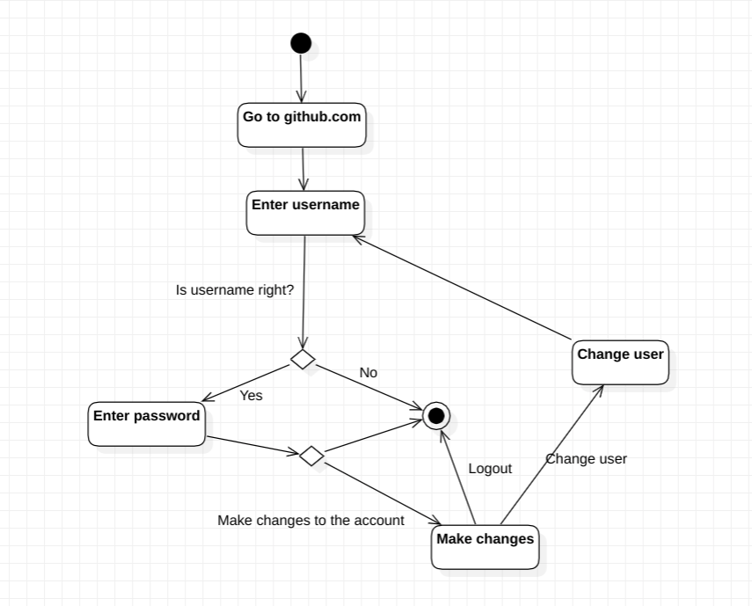

ii) The below activity diagram represents branch use case

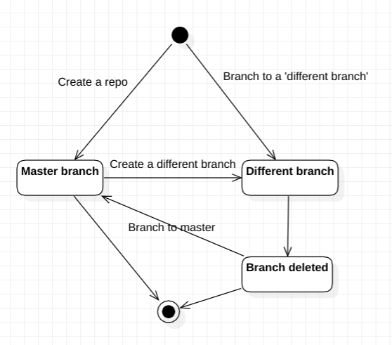

2: **State Diagram:**

The below state diagram represents Branch object.

